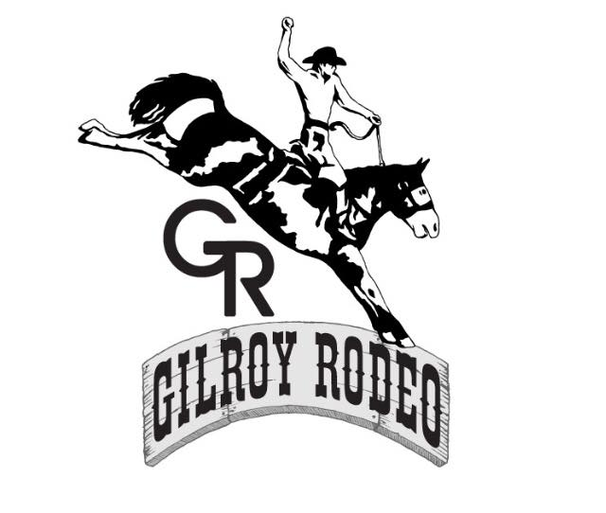
2021

2021 COMMERCIAL/MARKETPLACE BOOTH APPLICATION – Welcome
We are closely monitoring the situation with COVID-19 and working with Santa Clara County to ensure we meet all guidelines for Gilroy Rodeo 2021. Submitting this application in no way guarantees a vendor permit for our event. You will be contacted once you’ve been approved, checks will not be cashed until then.

Policies, Procedures & Requirements

DATE & TIME:
Friday, August 13th – Sunday, August 15th.
APPLICATION DEADLINE:
Applications will not be accepted after 5:00pm PDT, Friday, July 1, 2021! Submit application to vendors@gilroyrodeo.com or ATT: Vendor, P.O. BOX 1148 Gilroy, CA. 95021

APPLICATION PROCEDURE:
• This application should be filled out if you selling anything that is retail, buy & sell mixture of retail/Arts & Crafts or handcrafted by someone other than person selling the festival. If you are selling prepackaged foods, please fill out the prepackaged vendor application which has different requirements.
• If selling merchandise - completed application must include 2 photos of your items for sale and 1 photo of your booth display. Applications without photos will not be considered.
• Completed application and pictures can be emailed together if paying by credit card. If paying by check, please mail your application and payment. Pictures can be mailed with application or emailed separately. Please reference the company name on the email so we can match it up with the application, when received.
• If you would like your photos returned, please include a self-addressed stamped envelope, with enough postage to cover the cost to return your photos. Make sure you keep a copy for your records.
• List all items you will be selling or promoting/giveaways. Giveaways must be approved by management. Items and giveaways not included on the application will not be allowed to be sold, shown or given away. Festival management has the right to approve or deny any items for sale or promotion.
• All applications are date stamped and selected on a first come, first served basis. Each booth must have prominent signage identifying company name! Vendors not accepted will have all materials and fees returned. Cancellations prior July 20th can receive a refund, minus $50. processing fee. NO REFUNDS after August 1st!
• There is a $25 fee for returned checks.

SALES PERMIT:
The vendor is responsible for obtaining a current and valid sales permit prior to the event. Only public education institutions are exempt. This is not negotiable. A valid sales permit can be obtained from the State Board of Equalization office in San Jose at (408) 277-1231. Please make sure your permit is valid or your application will not be processed. You can check the status of your resale permit at https://efile.boe.ca.gov/boewebservices/verification.jsp. If exempt, write “exempt” and reason for exemption, on the application.
SELECTION:
• Selections are made based on quality, date received, duplication of items, and past participation in our event.
• The Committee’s decision is based on the needs of the Gilroy Rodeo and is final.
• Vendors will be notified of their acceptance in a timely manner. Those accepted will receive space assignment and set-up information the first week of August. All placement decisions are final. NO NEGOTIATIONS!
GENERAL INFORMATION:
• Vendor is provided a 12X12 SPACE ONLY. You are required to bring your own display, table, chairs, etc., to fit a 12X12 space. Tables and chairs are not available to borrow or rent from the Rodeo. Please make arrangements to provide your own. You must stay within your assigned area. The Gilroy Rodeo reserves the right to locate vendor booths according to the needs of the festival.
• No handing out flyers outside your booth. All displays, merchandise and staff must stay within your 12x12 space. Sandwich boards and merchandise outside your booth will NOT be tolerated. Sidewalks must remain open and clear at all times.
• Booth sharing is NOT allowed
• No sodas, bottled beverages and bottled water are allowed to be sold or handed out in vendor booths.
• Electrical service is not available. Quiet Generators are acceptable with approval.
• Overnight security will be provided. Each vendor is responsible for securing their own booth. The Rodeo is not responsible for any loss or theft incurred by any vendor.
• Access to your space will be available on Friday, August 9th from 2pm to 5pm or on Saturday August 10th from 6am to 8am. No Exceptions. Area must be clear of all vehicles by 8am. If you set up in the wrong booth space you will be asked to move. If you are not available to move your booth, Rodeo management has the right to move your booth and is not responsible for any damage.
• Vendors are responsible for removing their own trash from their area each evening and may not use Rodeo trash receptacles used by public for its disposal.
• The Gilroy Rodeo has the right to prohibit and/or evict (without refund or assumption of liability for lost sales or expenses) any presentation or person who is in any manner deemed offensive or unprofessional or not following these rules.
• All vendors agree to participate for the entire event and understand that tear down on Sunday before 6pm is not allowed for any reason.
• Gilroy can be windy after 4pm, so please be prepared. The vendor will be held liable in the event that their display causes damage to the display or work of another vendor or event site property or if anyone is injured due to your negligence.
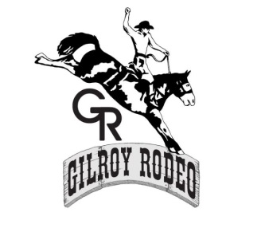
COMMERCIAL/MARKETPLACE APPLICATION
Application Deadline – July 15th, 2021
All fees must be submitted with application. Read the terms & conditions carefully and sign the acceptance of waiver, before returning your application. Applications won’t be accepted unless all necessary requirements and payment is returned with the completed application.
Last Name: _________________________First Name:__________________________ Vendor Business Name:___________________________________________________ Mailing Address:__________________________________________________________ City:____________________________State:______Zip Code:_____________________ Phone ( ) ________________ Fax ( ) ______________ Cell ( ) _______________ Email: ____________________________Website:______________________________ (Email address is for Gilroy Rodeo use only)
Resale Permit# (if selling merchandise/items):_________________________________ Resale permit must be valid and current. All resale numbers will be submitted to the State Board of Equalization as required by law. BOOTH INFORMATION (If selling retail, include 2 photos of items, 1 photo of booth display. Please include a self-addressed stamped envelope if you would like your pictures returned). Include a list of what you will be selling or promoting in your booth and any giveaways you will be doing ____________________________________________________________________________________________________________________________________________________________________________________________________________________________________________________________________________________________________________________________________________________ Special Requests (not guaranteed):_________________________________________
12x12 booth space $250 x ______spaces = $______ Nonprofit 501©3 $150 x ______spaces = $______ TOTAL $______
Mail your application and check to: Gilroy Rodeo ATT: VENDOR or Email application (can email pictures) to: vendors@gilroyrodeo.com

